sandboxcopy_**23**may_07 Marketo
has
**null**
workspaces. Stats below are a sum of assets found across all workspaces.

**Stats**

* They have **null** campaigns
* They have **null** active campaigns
* They have triggered campaigns
* They have **null** Active triggered campaigns
* They have **null** re-occurring batch campaigns
* They have **null** batch campaigns
* **null** landing pages
* **null** forms
* **null** emails
* **null**
  Snippets
* **null** uploaded files
* **null**
  Leads
* **null** programs

**Programs**

sandboxcopy_**23**may_07 Marketo, has created a lot of campaigns and content in Marketo. There are two types of smart campaigns: Batch and Trigger. A batch campaign launches at a specific time and affects a specific set of leads all at once. A triggered smart campaign affects one lead at a time, based on a triggered event. To learn more about Smart campaigns in Marketo. visit :https://docs.marketo.com/display/public/DOCS/Smart+Campaigns

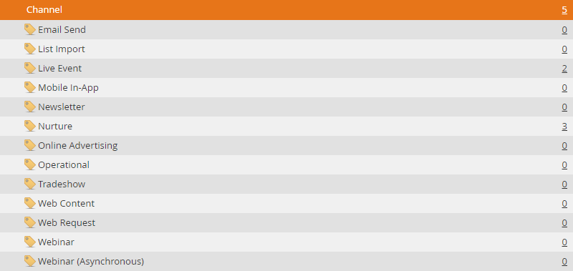

**Models**

**Lead Scoring**

* sandboxcopy_**23**may_07 Marketo
  has
  **1**
  lead scoring campaigns built out taking into account behavior,successes and decay. How are we checking this? Is the automation opeing the campaign and checking the flow step? Need to know how this is being checked.
* sandboxcopy_**23**may_07 Marketo,
  is executing multiple score changes with single campaigns.
* sandboxcopy_**23**may_07 Marketo
  is using MyTokens in their lead scoring campaigns which allows for a Marketer to quickly, and easily, control from a high level their lead change scores
* sandboxcopy_**23**may_07 Marketo
  has built
  **1**
  campaigns reducing lead scores when leads exhibit undesirable behavior

Marketo’s lead scoring capabilities are far more robust than any other vendor offerings.
Lead scoring allows you to identify which prospects are most interested and engaged with your brand. Marketo also allows the usage of My Tokens in lead scoring campaigns. This allows the marketer to have the ability to control at a high level all of the lead scoring attributes assigned to their campaigns. Additionally, Marketo allows the marketer to add detailed constraints to their lead scoring campaigns, which add a**not**her layer of complexity. For example – leads active during a specific date/time AND who visit the web page numerous times within a certain time window.

**Interesting Moment**

The following Interesting Moments have been defined to support
’s marketing campaigns. When a lead exhibits any of the below behavior, it will be documented and tracked.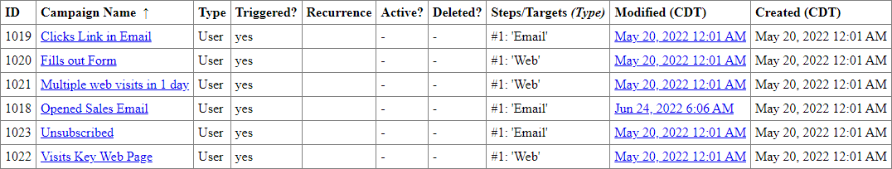

If you have Marketo Sales Insight, you can use the interesting moment flow step to give your sales team visibility into the cool things your leads are doing in a Smart Campaign. Interesting Moments allow the marketer to define what information is relevant to their sales team. When a lead takes a specific action, that action is logged and recorded for the team to see.

**Data Management**

sandboxcopy_**23**may_07 Marketo
has less than 5 data management actions set up. To determine this metric our team looks at the ‘Change Data Value’ flow step in the client’s campaigns. Each ‘Change Data Value’ flow step counts as a data management action.
Good examples of data management "
would be any steps taken to clean up lead data, for example, adding leads to a blacklist triggered by"
a certain action. Here is a walkthrough of how to do that: https://experienceleague.adobe.com/docs/marketo/using/product-docs/core-marketo-concepts/smart-lists-and-static-lists/managing-people-in-smart-lists/add-person-to-blocklist.html?lang=en
Here is a high overview on how to create Change Data Value flow actions: https://docs.marketo.com/display/public/DOCS/Change+Data+Value

**Events**

sandboxcopy_**23**may_07 Marketo
has
**2**
Event campaigns in Marketo.
One of the greatest features of Marketo is the ability to clone an entire program—which copies all underlying assets and campaigns that are part of that program. Events allow you to automate online and offline events! Capture the status of your leads as they progress through different stages and get accurate measures of the ROI for your marketing initiatives.
We should include the Alternate Verbiage **not**e here since this instance has less than 5 event campaigns:
“Since the client has less than 5 event campaigns we do suggest that you provide the following document on event campaigns:
https://docs.marketo.com/display/public/DOCS/Create+a+New+Event+Program.

**Nurture**sandboxcopy_**23**may_07 Marketo
has
**3**
Nurture campaigns using the Marketo Nurture Stream engine. There are two types of Content you can add to engagement program streams — emails and programs. Emails will be sentto leads at cast time. Marketo's smart streams also offer:

* **Intelligently and automatically deliver content to a target audience.**
* **Easily build dialogue with prospects and customers while preventing customers who have already received content from receiving the same content again.**
* **Add new content and entire programs to nurture streams.**
* **Edit the availability of content.**
* **Understand content performance based on engagement with each piece of content.**

We should include the Alternate Verbiage **not**e here since this instance has less than 5 nurture campaigns:
“Since the client has less than 5 nurture campaigns we do suggest that you provide the following document on event campaigns:
https://experienceleague.adobe.com/docs/marketo/using/product-docs/email-marketing/drip-nurturing/creating-an-engagement-program/create-an-engagement-program.html?lang=en .”

**Segmentation**

**Program Library**

It appears that
sandboxcopy_**23**may_07 Marketo
has imported templates from the Marketo Program Library.
Marketo is committed to our customers' success and has seeded a ton of pre-built programs for almost any use case into the Marketo Program Library that our customers are free to import when they are needed as their marketing strategies evolve and call for different types of programs and campaigns.

**Integrations**

The following integrations have been installed:

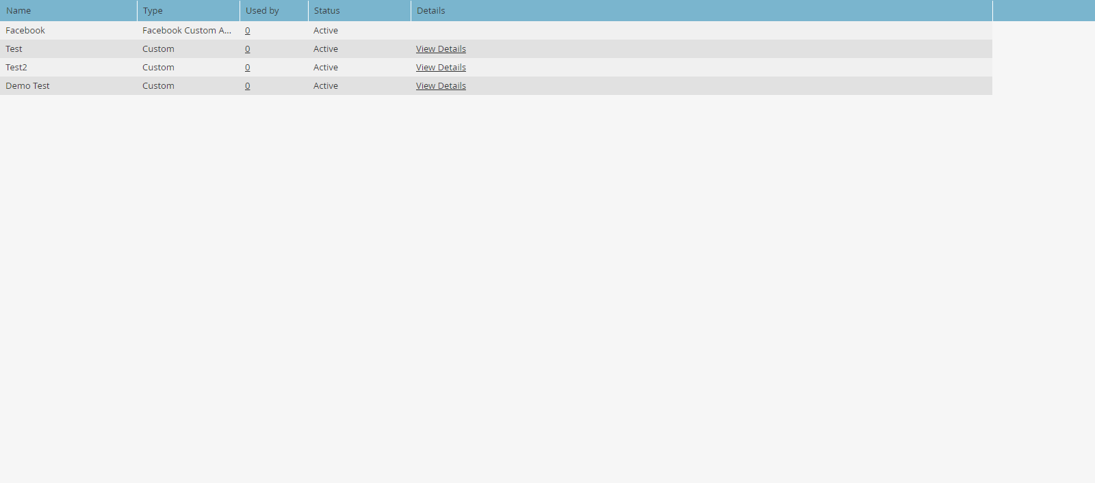

**Web Personalize**

With Marketo’s Real Time Personalization, you can engage the 98% of visitors that you don’t know. 98% of website visitors are anonymous, only **2**% are known. Using RTP, Marketers have an opportunity to engage these anonymous visitors with relevant content and personalized messages via web or mobile using firmographic and behavioral data. This real time personalization capability is completely unified within the platform and shares a common user experience, making it easy for marketers to create personalized web experiences without IT support. This results in increased conversion rates up to **3**0% and increased content engagement up to **2**70%. Competitors can**not** generate personalized web experiences for anonymous visitors, and personalization for known visitors is overly complicated

Top Campaigns: The top performing campaigns during the selected time period, ordered by number of clicks.D:\Builds\markketo-instance/Config/ScreenShot/Change Score.png  
D:\Builds\markketo-instance/Config/ScreenShot/Change Score.png  
D:\Builds\markketo-instance/Config/ScreenShot/Change Score.pngTD:\Builds\markketo-instance/Config/ScreenShot/Change Score.pngotal Organizations & Top 5 Organizations: The Organizations tab displays all the details (name, location, activity and time stamp) of organizations that visited your website during a given period. The table can be sorted and organized by time, location, domain and via a free text search.

**Predictive Content**

Content analytics allows you to gain further insights into your existing content, learn what content works for your audiences, and increase ROI from your marketing efforts.
With your Predictive Content Analytics, you can view Top Content by Views, Top Content by Conversion Rate, Trending Content, Suggested Content, and Content.